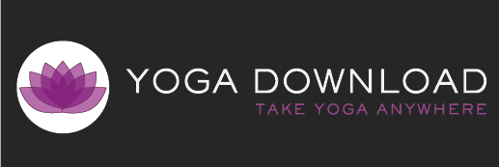 :smglogo_new.jpg

**#1 Site for Downloadable Yoga Classes Launches Revamped Yogadownload.com**

*Renowned Online Yoga Studio Debuts Completely Redesigned Website with Variety of Quality, Convenient, Portable and Affordable Classes from the Yoga Community’s Top Teachers*

**DENVER, CO – December 7, 2010** – Yoga Download, the premier online yoga studio offering downloadable audio and video classes for all styles and levels, announced today the launch of its all new website, [YogaDownload.com](http://www.yogadownload.com). In addition to a streamlined new design, fresh color palate and refined functionality, the new Yoga Download includes over 300 different yoga classes in a variety of lengths and styles, plus guided meditations and music, from some of the yoga community’s most renowned teachers. Each class is professionally mastered for optimal quality, allowing yogis to personalize their practice, in the comfort of home or out on the go, at their own pace.

Adding to its already extensive list of popular yoga teachers, the new Yoga Download site will launch with some fresh faces including Mind/Body Expert Ashley Turner, and the Colorado-based founder of the restful and healing Anjali Restorative Yoga, Shannon Paige Schneider. All classes are available for download in 20 to 90 minute formats and range from free to $6.99 with affordable monthly or annual subscription models also available.

“There’s really nothing else like YogaDownload.com,” said Yoga Download founder, Jamie Kent. “Whether you’re interested in Kundalini or weight loss, have 20 minutes to dedicate or an hour--there are top quality classes for every situation and for every type of practitioner. We are thrilled to offer a revamped site and introduce new teachers, while remaining dedicated to providing online yoga classes that are accessible, affordable and portable.”

Yoga Download will also soon include a comprehensive distribution platform, helping both teachers and students create their own classes and programs. Collaborations with a roster of independent world musicians and artists are also in development, providing an extensive listing of modern and traditional musical tracks to accompany each class.

**About Yoga Download**

YogaDownload.com is a privately-held company based in Denver, Colorado. Founded in 2006, YDL was created to make yoga practices more accessible, convenient and affordable. Combining the modern technology of portable media with the ancient practice of yoga, YDL provides personal, quality, customizable yoga classes—anytime, anywhere. YDL offers a wide variety of yoga styles, class lengths, teachers, music and pose guides to help each user maintain the benefits of the practice, with one simple download. To learn more, visit [YogaDownload.com](http://www.yogadownload.com)

Press Contact:

Saeger Media Group

Marci Mollins

O. 310.691.4518

E. marci@saegermediagroup.com